國立中央大學學生論文比對結果報告書
The Report of National Central University Student Thesis Similarity Check

姓名  Name |  | 系所  Department/Institute |  |  | 學號  Student ID
學年度  Academic Year |  | 身份  Program | □碩士班 Master's Program  □碩士在職專班 In-Service Master's Program  □博士班 Doctoral Program
提交版本  Version | □申請學位考試 For the Degree Examination  ■畢業離校時繳交系所 For the Department/Institute at Graduation
論文題目
Thesis Title
檢測軟體  Detection Software | Turnitin 論文原創性比對
檢測日期
Date of Detection
篩選條件  Filter Criteria | 「排除引用」、「參考文獻」、「小型相似來源資料」等均不得選取排除
相似度比對截圖  (範本如右)  Similarity Comparison Screenshot  (Example as shown on the right) | 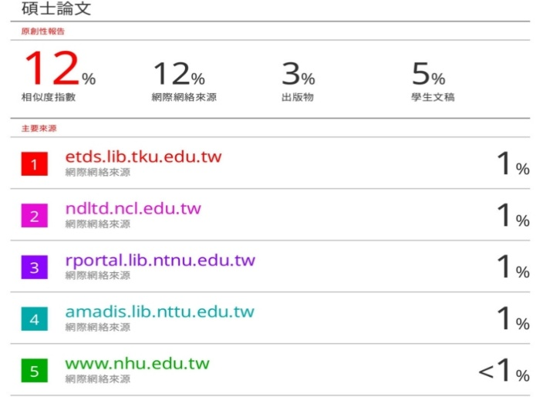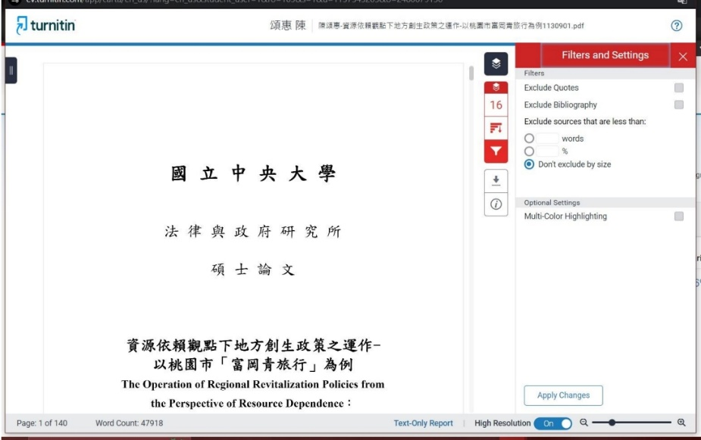
系所規定標準值  Standard Threshold Specified by Department/Institute | 30%
指導教授簽名  Thesis Advisor's Signature |  |  | 日期  Date
學生簽名  Student's Signature |  |  | 日期  Date
相關條文  Relevant Regulation | 本校「博士班、碩士班研究生學位考試細則」  第十二條第一項 請指導教授與研究生親筆簽名確認口試論文之比對結果符合系所規定要求，送至系所辦公室存查。  National Central University Regulations on Degree Examinations for Postgraduate Students  Article 1, Paragraph 1  The student and the thesis advisor of the student shall sign the Report of NCU Student Thesis Similarity Check in person to confirm that the thesis similarity comparison result meets the requirements established by their department/institute.
113.11.13

